User Manual

Authors: Vinh Mai – Philip Dube

# Introduction:

## 1.1 Scope and Purpose

Foprm, ‘Fast Organised Patient Records Manager”, is a fast, organized and beginner friendly application with some most useful features such as creating view, update and post profiles much easier than dealing with papers helping to improve the work speed.

Throughout the user manual, you will find how to use and get the most out of the Foprm’s features such as “Create”, “View”, “Edit/Update”, “Merge” and “Print”.

## Application Workplace

### Main Screen

### Create

### Find

### Merge

### View

#### View Mode

#### Edit/Update Mode

# User Guide:

## Create Patient Profile

1. Click “Create” on Main Screen to open “Create Screen”

1. Input Patient’ information:

1. Click “Create”

## Search/Find Patient Profile-s

1. Click “Create” on Main Screen to open “Create Screen”

1. Input at least 1 patient’ information

1. Click “Find”

-After “Find”-

## Merge Patients’ profiles

1. Click “Merge” on Main Screen to open “Merge Screen”

1. Select 2 Patients. Note: Result’s Patient ID will be based on First Patient/Patient 1

1. Select Information want to keep (All required)

1. Click “Merge”

## View Patient Profile

### 2.4.1 View Mode

1. Select wanted record by clicking on from the list

1. Click “View”

### Edit/Update Mode

1. Enter Edit/Update Mode by clicking on “Edit Mode” on View Screen

1. Input changes

1. Click “Confirm Update”

-After updated-

## Remove a Patient Profile

1. Select wanted record-s by clicking on from the list (Hold “Ctrl” for multiple select)

1. Click “Remove”

--Printed file locates in Foprm’s subfolder called Documents--

## 2.6 Print report

--Printed file locates in App’s subfolder called Documents--

### 2.6.1 Print wanted record-s:

1. Select wanted record-s by clicking on from the list (Hold “Ctrl” for multiple select)

1. Click “Print” and confirm.

After pressing Yes this Box will pop up

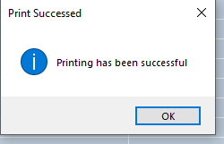

After pressing Ok you will return to the main form

### 2.6.2 Print screen:

1. Click “Print” with no records selected

After pressing Yes this Box will pop up



After pressing Ok you will return to the main form

## 2. 7 Sort:

1. Sort Ascending/Descending by click the header (ID, First Name, Last Name, Gender, Condition)

## 2.8 JSON storing data:

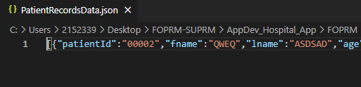

Load JSON file on open to initialize data and using JSON to store Patient’ changes/data allow the user would be able to get back to where they left off after re-opening the app.

## Refresh:

After performing “Find” and “Sort”, user may find themselves being stuck in the result screen. To refresh the list view, press “F5” or click “Refresh”.

-Thank you for using our product -